**PALAUAN LANGUAGE**

**https://24x7offshoring.com/**

[**http://24x7outsourcing.com/**](http://24x7outsourcing.com/)

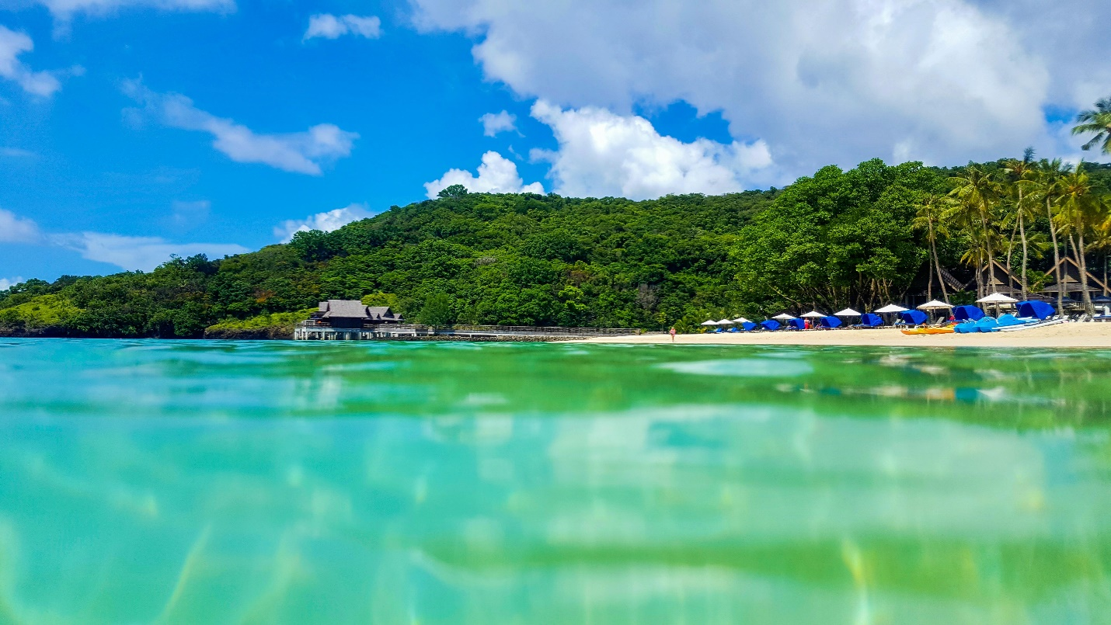

**Palauan Language Tralsnation**

**Brief Introduction of Palau and Palauan**

Republic of Palau (Beluu er a Belau) is a nation of 340 islands with various regions in Percific.

From 1994, Palau is managed by USA.

**Significant ventures**

The significant ventures are fishery and the travel industry. The greater part of individuals here trust in Christianity and modekngei; 70% populace are nearby Micronesian, the rest are Filipinos.

In Palau, there 16 states. The biggest principle island is partitioned into 14 expresses, the rest islands are separated into two from south to north.

**16 states**

The 16 states are:

Aimeliik, Airai, Angaur, Hatohobei, Kayangel, Koror, Melekeok, Ngaraard, Ngarchelong, Ngardmau, Ngatpang, Ngchesar, Ngaremlengui, Ngiwal, Peleliu and Sonsorol.

There are two authority language spoken in Republic of Palau, one is obviously English, the other is Palauan (additionally spelled as Belauan).

Palauan has a place with Austronesian group of language. Diverse with its neighbor dialects, Palauan isn't a Micronesian language. All things considered, it is something very similar with Chamorro, has a place with an autonomous part of Malayo-Polynesian language.

There are absolutely 6 vowels and 10 consonants in Palauan. If it's not too much trouble, see the accompanying tables for subtleties.

**Vowel Phonemes**

Back Central Front

High u i

Mid o ə ɛ

Low a

**Consonant Phonemes**

Glottal Velar Alveolar Labial

Voiceless

Stops ʔ k t

Voiced

Stops d b

Voiceless

Fricatives s

Nasals ŋ m

Liquids l, ɾ

**Additionally, there are a few diphthongs as follows:**

Diphthongs

IPA Example English Translation

/iɛ/ babier "paper" (German advance)

/ɛi/ mei "come"

/iu/ chiukl "(singing) voice"

/ui/ tuich "torch"

/io/ kikiongel "dirty"

/oi/ tekoi "language"

/ia/ diall "ship"

/ai/ chais "news"

/ɛu/ teu "width"

/uɛ/ sueleb "afternoon"

/ɛo/ Oreor "Koror" (previous capital of Palau)

/oɛ/ beroel "spear"

/ɛa/ beached "tin"

/aɛ/ baeb "pipe" (English advance)

/uo/ uos "horse"

/ou/ merous "distribute"

/ua/ tuangel "door"

/au/ mesaul "tired"

/oa/ omoachel "river"

/ao/ taod "fork"

Palauan language is with the word request of VOS that is action word object-subject.

For example, Ak milenga er a ringngo star. (Signifies: "I ate the apple.")

The invalid pronoun ace is the subject "I," the statement starting ak is the principal individual particular subject arrangement morpheme.

Palauan localozation administration with 24X7OFFSHORING.COM

Do you require Palauan interpretation administration?

Is it accurate to say that you are discovering somebody assist you with Palauan confinement arrangement?

24X7OFFSHORING.COM is the most ideal decision for you!

**24X7OFFSHORING.COM applies TEP measure for confinement seivices:**

T – Local Palauan interpreters with pertinent backgroung of the interpretation material

E – Palauan editors to alter record, guaranteeing exac comprehension and accuration articulation

P – Proofreaders go through the altered record to kill any second rate botches

24X7OFFSHORING.COM is an expert confinement administration organization.

We have abountant local expert Palauan interpreters and editors in various fileds; stict QA work process framework to guarantee best quality; amazing Palauan designs in-house to give best confinement servise of Palauan site.

We committed to provide best quality with affordable price.

24/7 service waiting for you.

For more information, please visit www.24x7offshoring.com.

**PALAUAN LANGUAGE**

**https://24x7offshoring.com/**

**http://24x7outsourcing.com/**